Following on from a few messages about the entry process and observations that the Entry Central system is not as user friendly as we would all like, Tri Dog have put together this simple step by step guide to assist any newcomers to Tri Dog and Entry Central. We hope it helps.
_______

For Tri Dog to offer as many race combinations as our competitors desire, we have to list each option as an individual item.

To help people complete their entry forms and, in addition, to help explain how the Entry Central percentage service charge accumulates, Tri Dog has put together this brief tutorial.

We hope this explanation makes things a little clearer.

We look forward to seeing you at our event.

Step 01
Select Sign Up
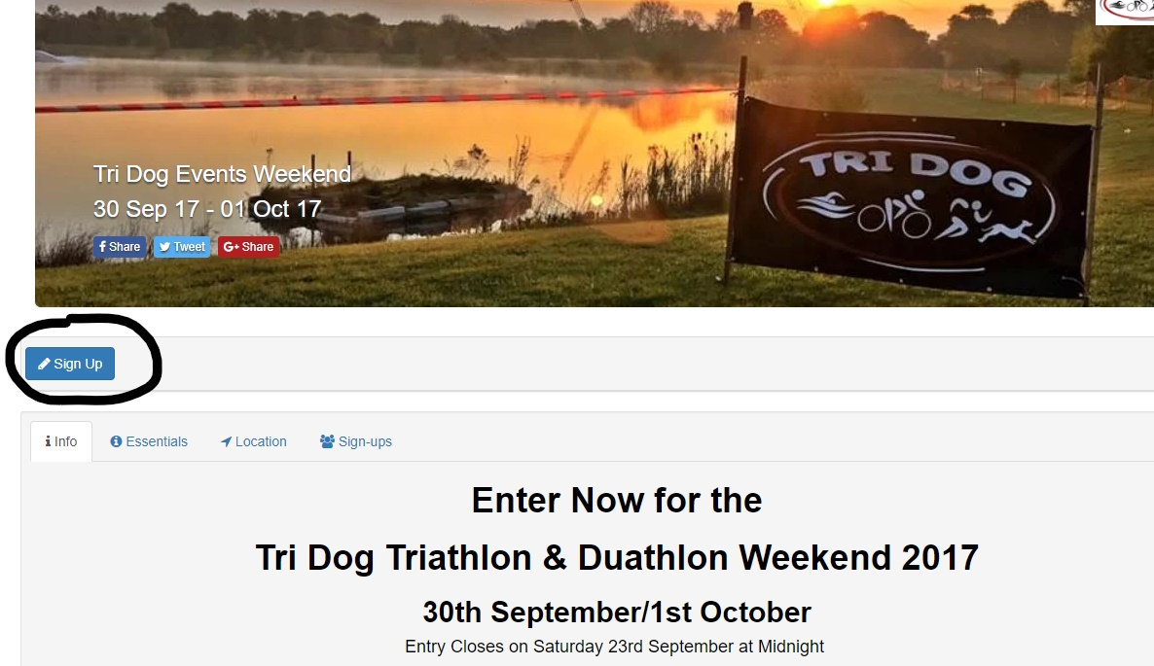

Step 2
From the drop down menu select option required
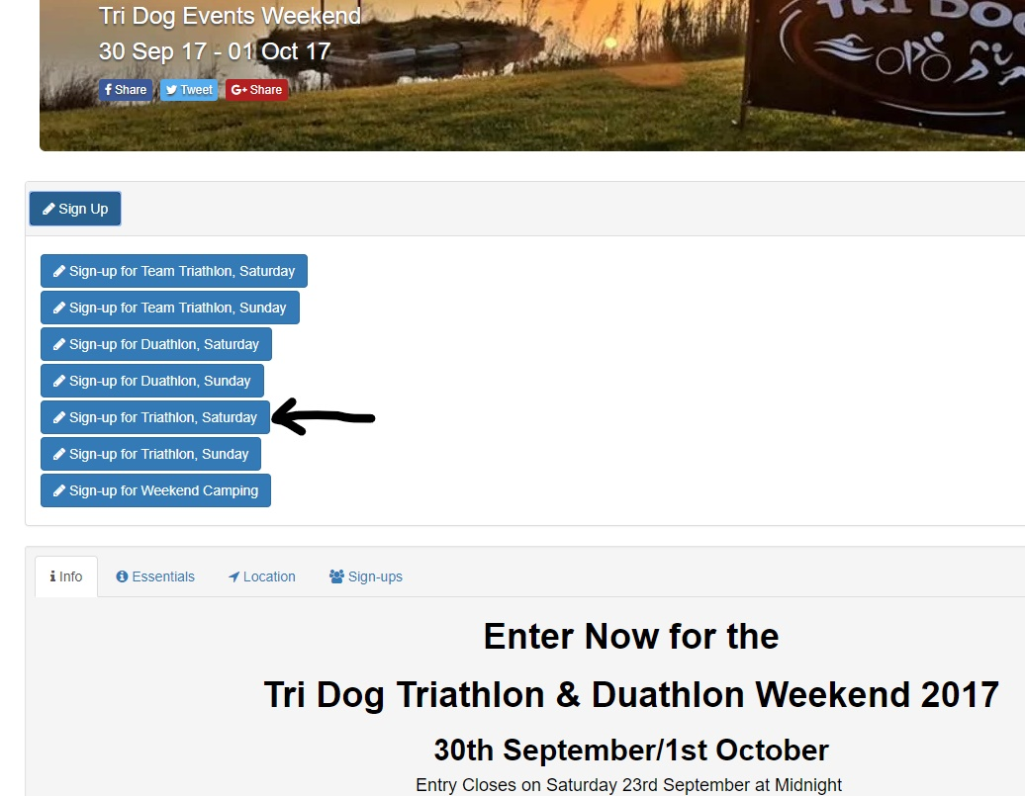

Step 3
Complete all the details asked for on the personal details form and remember to check the Remember Me box before selecting Next
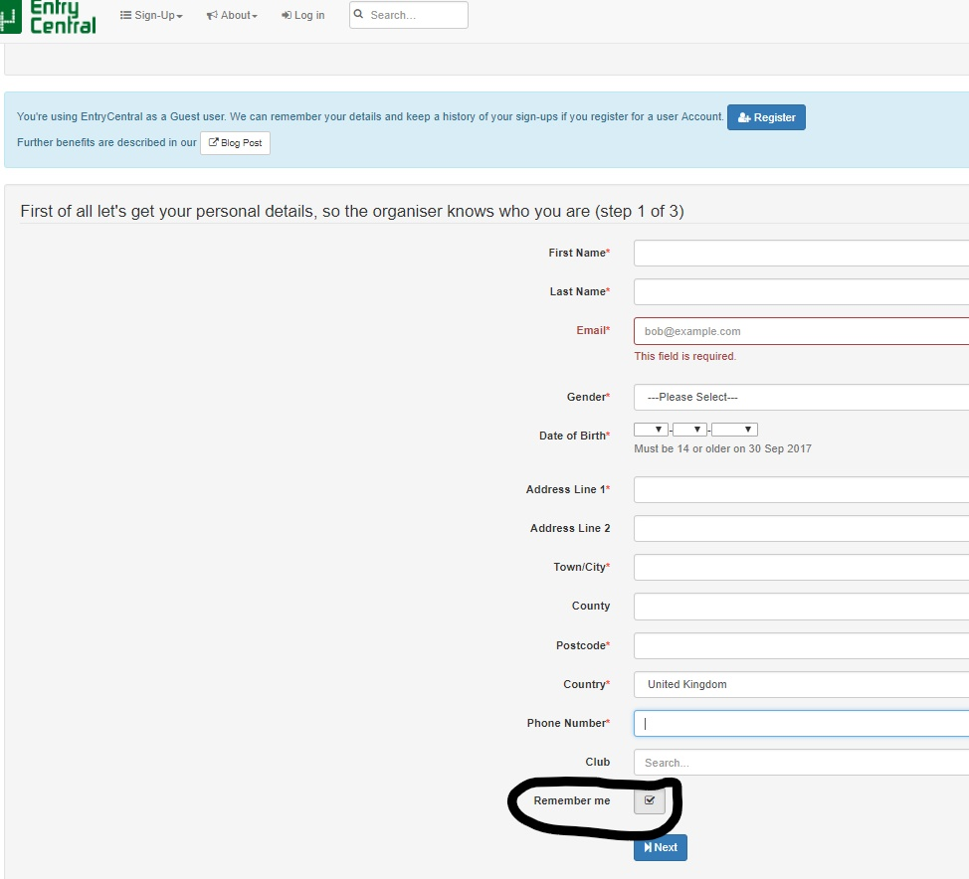

Step 4
Complete item details
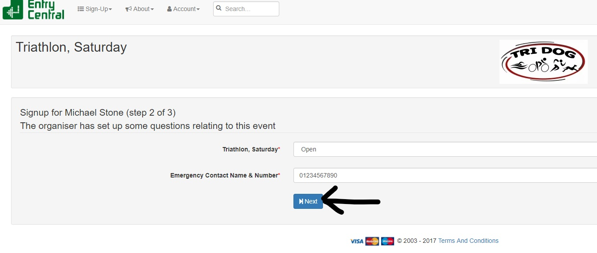

Step 5
Check submitted details and tick relevant boxes
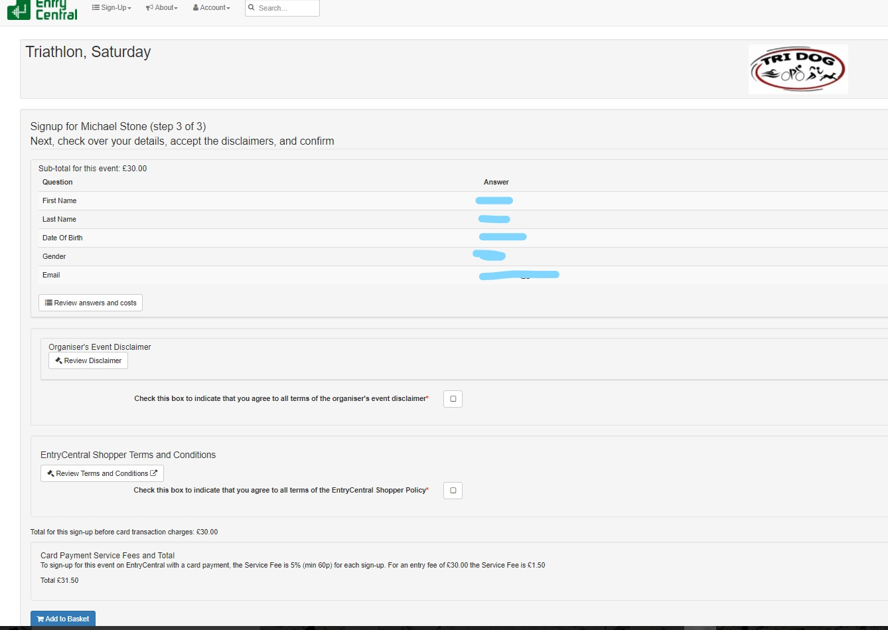

Step 6
Please note that Entry Central’s percentage policy means you do pay the same amount in their service charge regardless of it being three transactions or one.
Add to basket
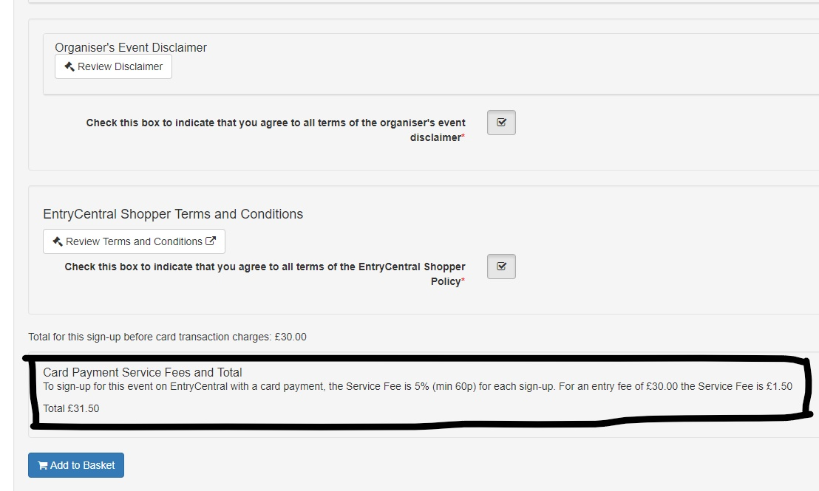

Step 7
If you are entering more than one day or more than one event select +Add Another
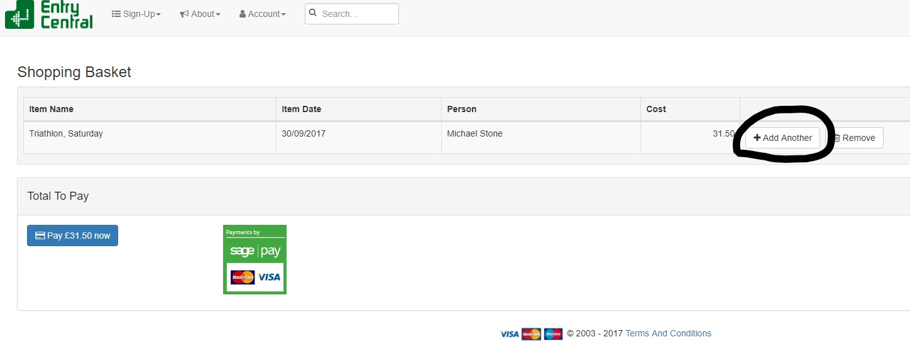

Step 8
You will be returned to the original sign up page where you need to select your next item. The process outlined above is then repeated.
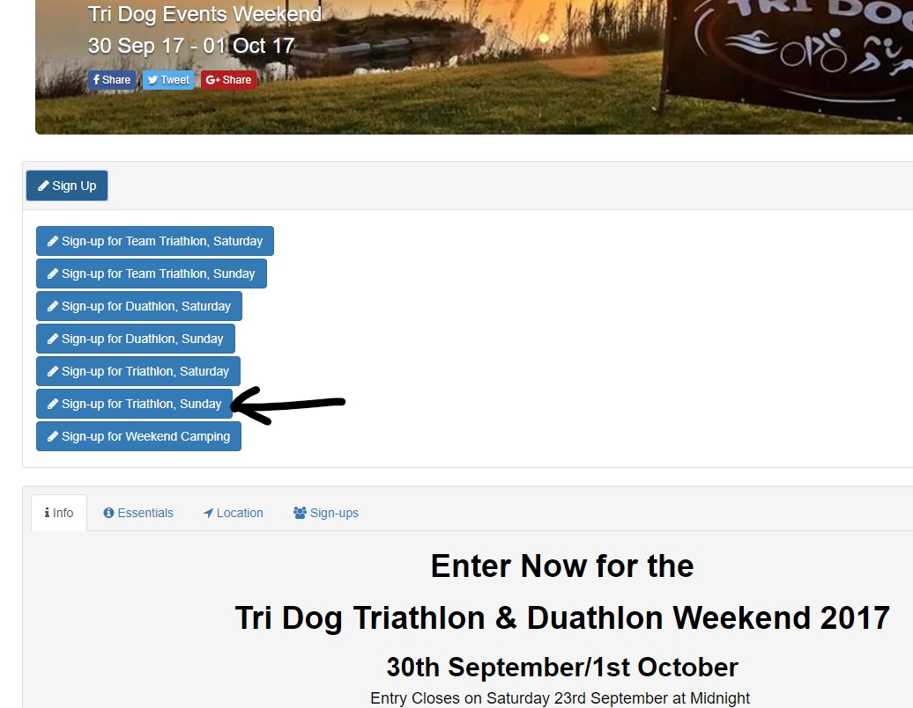

Step 9
Once all events have been selected if camping is required, select +Add Another
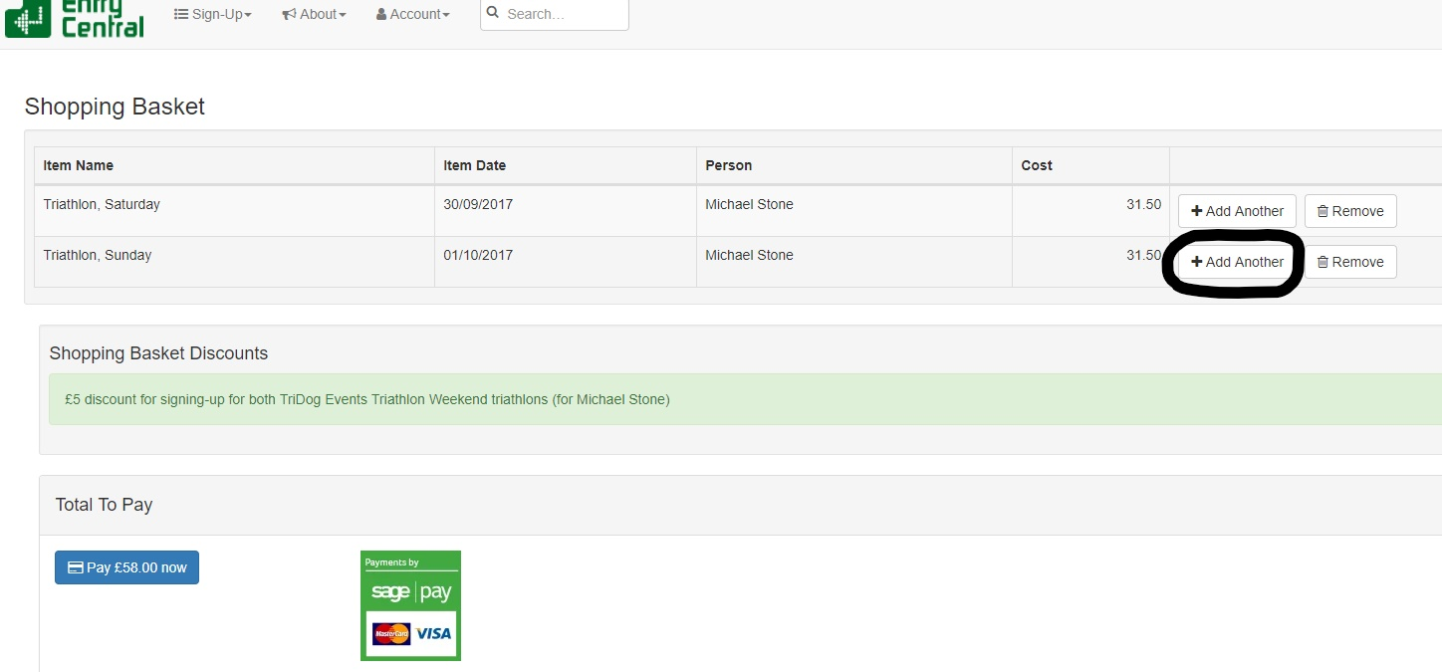

Step 10
Select the camping option
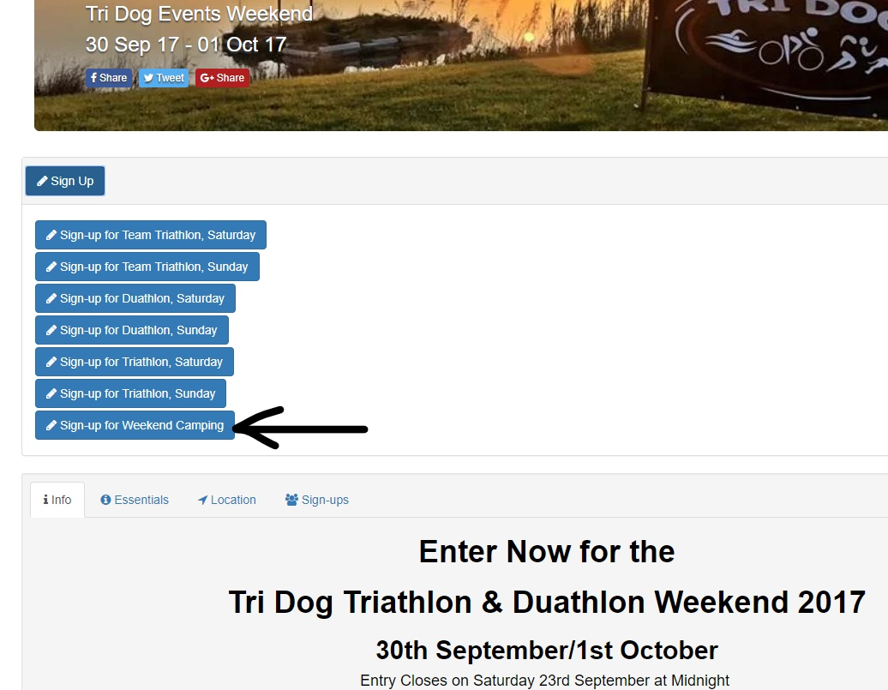

Step 11
Complete the drop down menus and select next
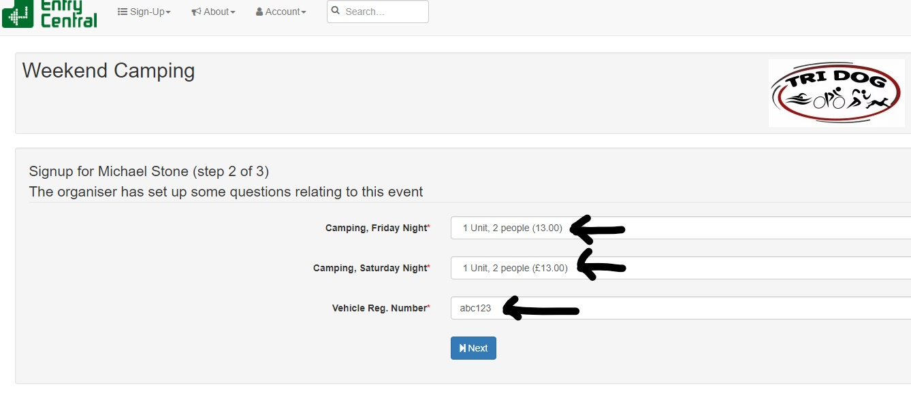

Step 12
Check details and add to basket
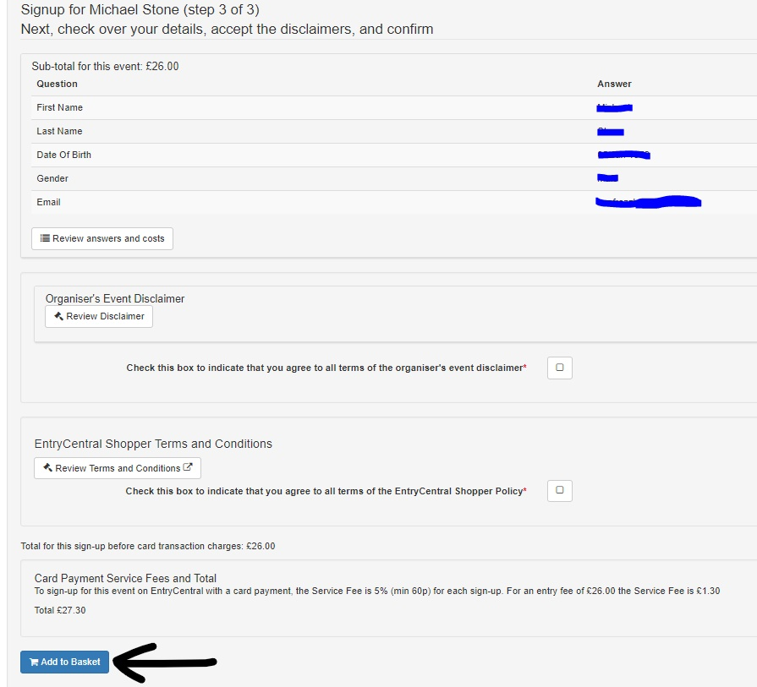

Step 13
When your basket is complete select Pay Now
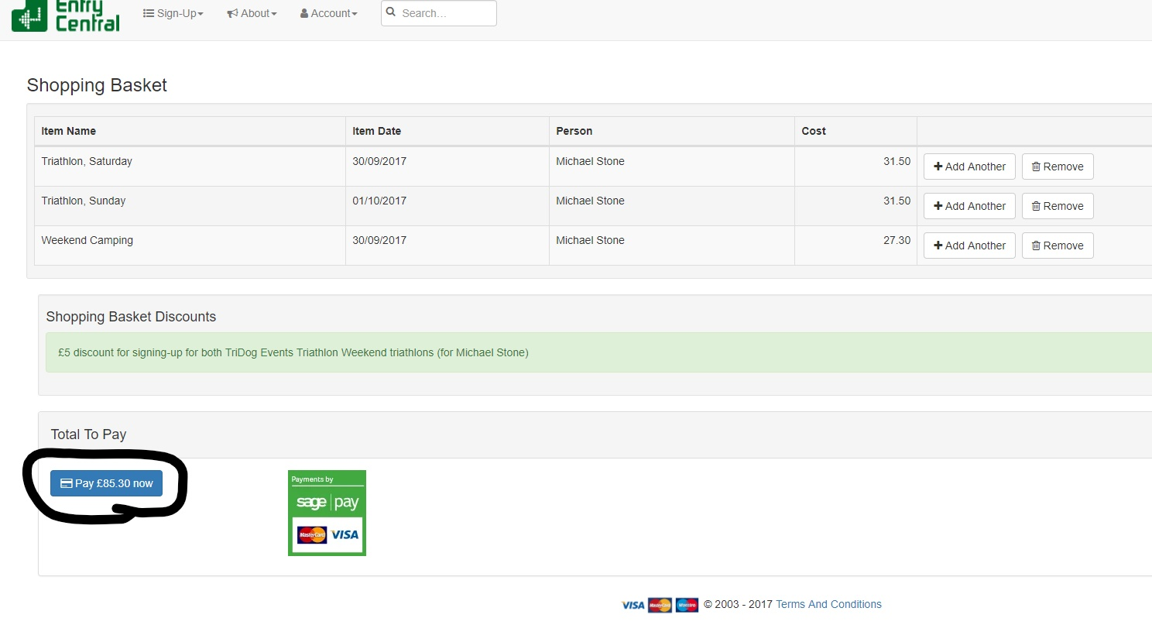

Step 14
On the payment page select payment method
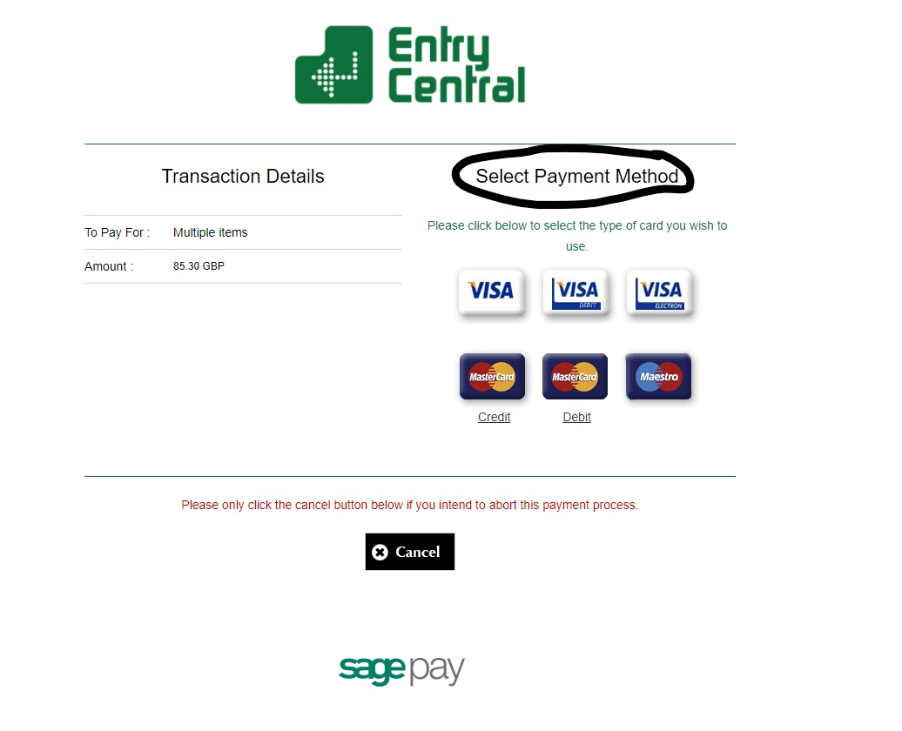

Step 15
When to whole process has been completed you will receive entry confirmation emails from Entry Central

